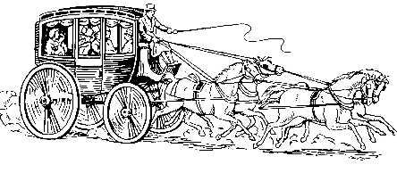
2023 Stagecoach Parade
Registration Application

Join us for our Stagecoach Days Parade Saturday, August 5th, 2023! We will begin the parade at Access Road and end at Fuls Rd.
Line up begins at 10am. Parade will begin at 11am.

All participants must have family friendly content
Free Entry. Donations appreciated.
(All donations go back to Stagecoach.)

Business/Organization Name:________________________________________
Contact Name:
Phone Number:
Email Address:
Second Contact Name:
Phone Number:
Email Address:

Description of your float/contribution:

